**Id 32 bits unsigned**

**MCP2515.RESET()**

{

SPI.transfer(0xc0)

SPI.START()

SPI.transfer(0x02)

SPI.transfer(mcp_TXB0CTRL) 0x30

SPI.transfer(0x00)

SPI.transfer(0x00)

SPI.transfer(0x00)

SPI.transfer(0x00)

SPI.transfer(0x00)

SPI.transfer(0x00)

SPI.transfer(0x00)

SPI.transfer(0x00)

SPI.transfer(0x00)

SPI.transfer(0x00)

SPI.transfer(0x00)

SPI.transfer(0x00)

SPI.transfer(0x00)

SPI.transfer(0x00)

EndSPI();

SPI.START()

SPI.transfer(0x02)

SPI.transfer(mcp_TXB1CTRL) 0x40

SPI.transfer(0x00)

SPI.transfer(0x00)

SPI.transfer(0x00)

SPI.transfer(0x00)

SPI.transfer(0x00)

SPI.transfer(0x00)

SPI.transfer(0x00)

SPI.transfer(0x00)

SPI.transfer(0x00)

SPI.transfer(0x00)

SPI.transfer(0x00)

SPI.transfer(0x00)

SPI.transfer(0x00)

SPI.transfer(0x00)

EndSPI();

SPI.START()

SPI.transfer(0x02)

SPI.transfer(mcp_TXB2CTRL) 0x50

SPI.transfer(0x00)

SPI.transfer(0x00)

SPI.transfer(0x00)

SPI.transfer(0x00)

SPI.transfer(0x00)

SPI.transfer(0x00)

SPI.transfer(0x00)

SPI.transfer(0x00)

SPI.transfer(0x00)

SPI.transfer(0x00)

SPI.transfer(0x00)

SPI.transfer(0x00)

SPI.transfer(0x00)

SPI.transfer(0x00)

EndSPI();

SPI.START()

SPI.transfer(0x02)

SPI.transfer(MCP_RXB0CTRL) 0x60

SPI.transfer(0x00)

EndSPI();

SPI.START()

SPI.transfer(0x02)

SPI.transfer(MCP_RXB1CTRL) 0x70

SPI.transfer(0x00)

EndSPI();

SPI.START()

SPI.transfer(0x02)

SPI.transfer(MCP_CANINTE) 0x2B

aa = CANINTF_RX0IF | CANINTF_RX1IF | CANINTF_ERRIF | CANINTF_MERRF

aa = 0x01 | 0x02 | 0x20 | 0x80 = A3

SPI.transfer(0xA3)

EndSPI();

SPI.START()

SPI.transfer(INSTRUCTION_BITMOD) 0x05

SPI.transfer(MCP_RXB0CTRL) 0x60

aa = RXBnCTRL_RXM_MASK | RXB0CTRL_BUKT | RXB0CTRL_FILHIT_MASK | RXBnCTRL_RXM_STDEXT | RXB0CTRL_BUKT | RXB0CTRL_FILHIT

aa = 0x60 | 0x04 | 0x03 | 0x00 | 0x04 | 0x00 = 67

SPI.transfer(0x67)

EndSPI();

SPI.START()

SPI.transfer(INSTRUCTION_BITMOD) 0x05

SPI.transfer(MCP_RXB1CTRL) 0x70

aa = RXBnCTRL_RXM_MASK | RXB1CTRL_FILHIT_MASK | RXBnCTRL_RXM_STDEXT | RXB1CTRL_FILHIT)

aa = 0x60 | 0x07 | 0x00 | 0x01 = 67

SPI.transfer(0x67)

EndSPI();

setFilter(filters[i], ext, 0)

setConfigMode();

setMode(CANCTRL_REQOP_CONFIG);

modifyRegister(MCP_CANCTRL, CANCTRL_REQOP,CANCTRL_REQOP_CONFIG);

SET FILTER UNA VEZ POR CADA MÁSCARA mask = RXF0, RXF1, RXF2, RXF3, RXF4, RXF5

bool ext = (i == 1);

StartSPI()

SPI.transfer(INSTRUCTION_BITMOD) 0X05

SPI.transfer(MCP_CANCTRL) 0X0F

SPI.transfer(CANCTRL_REQOP) 0XE0

SPI.transfer(CANCTRL_REQOP_CONFIG) 0X80

END SPI

reg = MCP_RXF0SIDH;

prepareId(uint8_t *buffer, const bool ext, const uint32_t id)

uint16_t canid = (uint16_t)(id & 0x0FFFF);

if(ext)

{

buffer[MCP_EID0] = (uint8_t) (canid & 0xFF);

buffer[MCP_EID8] = (uint8_t) (canid >> 8);

canid = (uint16_t)(id >> 16);

buffer[MCP_SIDL] = (uint8_t) (canid & 0x03);

buffer[MCP_SIDL] += (uint8_t) ((canid & 0x1C) << 3);

buffer[MCP_SIDL] |= TXB_EXIDE_MASK;

buffer[MCP_SIDH] = (uint8_t) (canid >> 5);

}

Else{

buffer[MCP_SIDH] = (uint8_t) (canid >> 3);

buffer[MCP_SIDL] = (uint8_t) ((canid & 0x07 ) << 5);

buffer[MCP_EID0] = 0;

buffer[MCP_EID8] = 0;

}

setRegisters(reg, tbufdata, 4);

startSPI()

SPI.transfer(INSTRUCTION_WRITE) 0x02

SPI.transfer(MCP_RXF0SIDH)

FOR(INT I = 0; I < N; I++)

{

SPI.transfer(buffer[i]);

}

FIN SET FILTER;

MASK masks[] = {MASK0, MASK1};

for (int i=0; i<2; i++) {

setFilterMask(masks[i], true, 0);

}

setFilterMask

{

StartSPI();

SPI.transfer(INSTRUCCIÓN_BITMOD) 0X05

SPI.transfer(mcp_canctrl) 0x0F

SPI.transfer(canctrl_reqop) 0XE0

SPI.transfer(CANCTRL_REQOP_CONFIG) 0x80

ENDSPI

}

}

**SETBITRATE**

**mcp2515.setBitrate(CAN_125KBPS,MCP_8MHZ);**

cfg1 = MCP_8MHz_125kBPS_CFG1;

cfg2 = MCP_8MHz_125kBPS_CFG2;

cfg3 = MCP_8MHz_125kBPS_CFG3;

setRegister(MCP_CNF1, cfg1); 0x2A 0x01

StartSPI();

SPI.transfer(INSTRUCTION_WRITE) 0x02

SPI.transfer(MCP_CNF1) 0x2A

SPI.transfer(cfg1) 0x01

ENDSPI()

setRegister(MCP_CNF2, cfg2); 0x29 0XB1

StartSPI();

SPI.transfer(INSTRUCTION_WRITE) 0x02

SPI.transfer(MCP_CNF2) 0x2A

SPI.transfer(cfg2) 0x01

ENDSPI()

setRegister(MCP_CNF3, cfg3); 0x28 0x85

StartSPI();

SPI.transfer(INSTRUCTION_WRITE) 0x02

SPI.transfer(MCP_CNF3) 0x2A

SPI.transfer(cfg3) 0x01

ENDSPI()

**FINSETBITRATE**

**setMode(CANCTRL_REQOP_NORMAL);**

modifyRegister(MCP_CANCTRL, CANCTRL_REQOP, CANCTRL_REQOP_NORMAL);

StartSPI();

SPI.transfer(INSTRUCTION_BITMOD) 0x05

SPI.transfer(MCP_CANCTRL) 0x0F

SPI.transfer(CANCTRL_REQOP) 0Xe0

SPI.transfer(CANCTRL_REQOP_NORMAL) 0x00

ENDSPI;

**MCP2515::readMessage(struct can_frame *frame)**

GetSTATUS()

STARTSPI()

SPI.TRANSFER(INSTRUCTION_READ_STATUS)

Rx_data <= MISO_byte

endSPI; 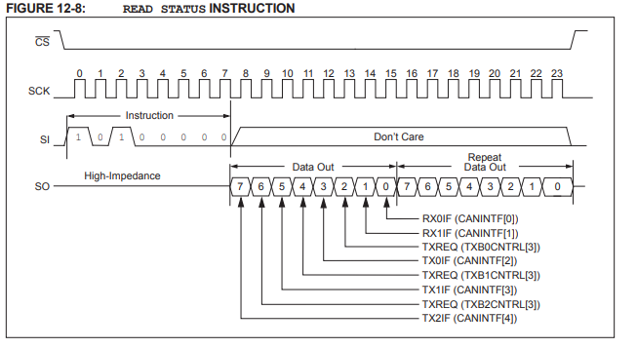

if(Rx_data & STAT_RX0IF) then 0x01

readMessage(RXB0, frame);

} else if ( stat & STAT_RX1IF ) { 0x02

rc = readMessage(RXB1, frame);

end if;

READ MESSAGE

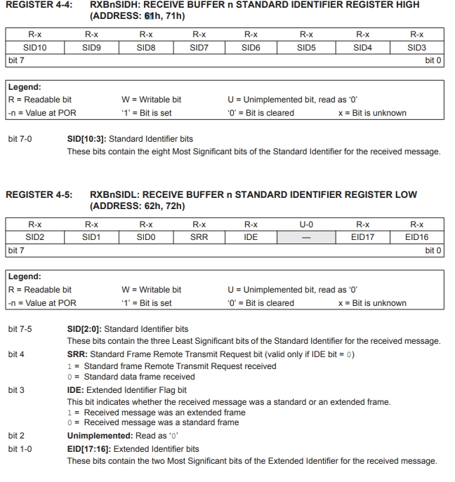

readRegisters(rxb->SIDH, tbufdata, 5);

STARTSPI()

SPI.transfer(Instruction_READ) 0x03

SPI.transfer(SIDH) 0x61

For(int i = 0; i < 5 ; i++)

{

DATOS[I] = SPI.READ;

}

ID = (DATOS[MCP_SIDH]<<3) + (DATOS[MCP_SIDL]>>5);

if ( (tbufdata[MCP_SIDL] & TXB_EXIDE_MASK) == TXB_EXIDE_MASK ) {

id = (id<<2) + (tbufdata[MCP_SIDL] & 0x03);

id = (id<<8) + tbufdata[MCP_EID8];

id = (id<<8) + tbufdata[MCP_EID0];

id |= CAN_EFF_FLAG;

END IF;

dlc = (DATOS [MCP_DLC] & DLC_MASK); 0x0F

readRegister(rxb->CTRL)

STARTSPI()

SPI.transfer(Instruction_READ) 0x03

SPI.transfer(CTRL) 0x61

if (ctrl & RXBnCTRL_RTR) { 0x08 00001000 //si crtl tiene al menos un 1

id = id | CAN_RTR_FLAG; 0x40000000UL //or bit a bit

end if;

readRegisters(rxb->DATA, frame->data, dlc);

SPI.start()

SPI.transfer(InstructionREAD) 0x03

DATA[0] = SPI.transfer(0x66);

For(int i = 1 ; i < dlc; i++)

DATA[1] = SPI.transfer(0x66 + i)

END FOR

modifyRegister(MCP_CANINTF, 0x03, 0); 0x20

CANINTF_RX0IF = 0x01, CANINTF_RX1IF = 0x02, => 0x03